**AREA DESCRIPTION**

The square area used in the project is bounded by longitudes (73.160 - 79.365) and latitudes (24.277 - 28.150) .The square area is part of north India consisting portions of three states which are Rajasthan, Uttar Pradesh and Madhya Pradesh. I have selected Jaipur city for the project .Other cities like Agra, Kota and Gwalior also have some portions in the square area.

The custom area can be downloaded from overpass-api using the query:

<union>

<bbox-query> s=”24.277” w=”73.160” n=”28.150” e=”79.365”/>

<recurse type=”up”/>

</union>

<printmode=”meta”/>

**Links:**

* <https://www.openstreetmap.org/export#map=5/26.215/76.289>
* <http://overpass-api.de/query_form.html>

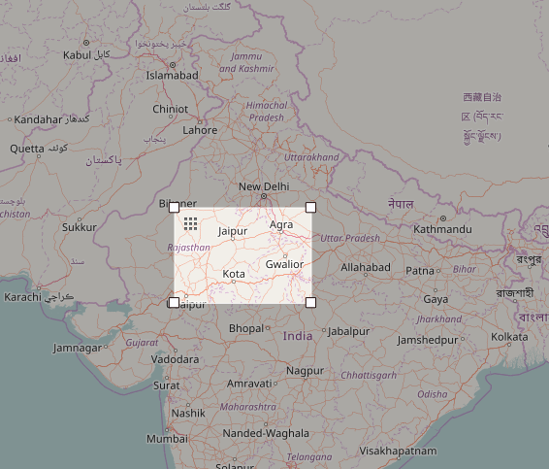

I have selected this area because Jaipur is my hometown so I was interested in knowing more about the data available on open street maps for my city. I was excited to contribute to OpenStreetMaps.org and improve the quality of my city data. I used overpass-api to select Jaipur city because there was no predefined dataset for this city.